***On my honor, I pledge that I have not violated the provisions of the NJIT Student Honor Code***

STUDENT TEAM No__**2**__

Name Signature

…Arsh Bhamla………… ___**ARSH BHAMLA~~___~~**_ …Pranay KC………….. _**_PRANAY RAJ KC_____** ..Shreedhar Rajendran. **__Shreedhar Rajendran—**

..Christopher Karkenny. __**Christopher Karkenny**_

Experiment performed on date _04/ 04 / 2025__

Report submitted on date ___04/06/2025______

Returned for corrections on date _________ Grade ______

Returned after corrections on date _________ Grade ______

**Introduction**

In this lab experiment, we will be looking at how the internal resistance of measurement tools can affect how electronic circuits work. In past experiments, we built circuits and measured their properties using tools like voltmeters, ammeters, and oscilloscopes. In the real world, these instruments have internal resistances and sometimes even impedances with capacitive and inductive elements that can actually change how current and voltage are distributed. These changes can mess up measurements and make them less accurate such as if a voltmeter pulls in too much current or an ammeter causes a noticeable voltage drop. We will be measuring the internal resistance of common lab instruments like digital and analog voltmeters, ammeters, and waveform generators and show how these resistances impact circuit behavior.

**Procedure**

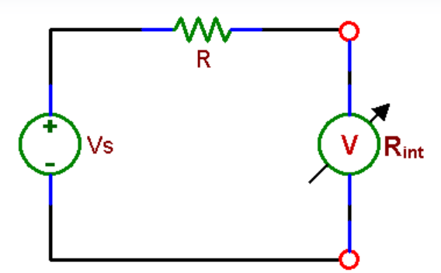

*Fig. 4.1: Measurement of the internal resistance of a voltmeter.*

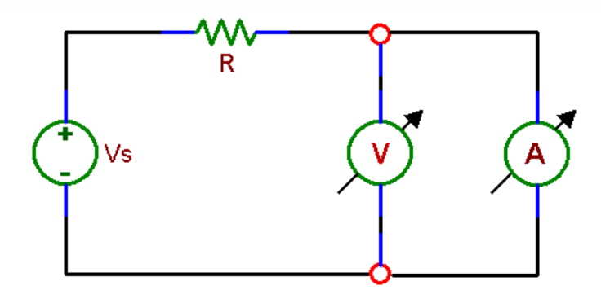

*Fig. 4.2: Measurement of the internal resistance of an analog ammeter with a digital voltmeter.*

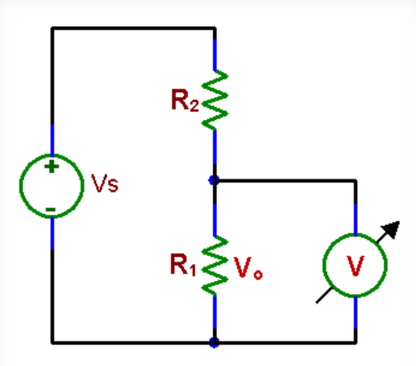

*Fig 4.3: A resistive voltage divider*

*Figures shown taken from* [*lab manual*](https://ecelabs.njit.edu/ece294/lab8.php)

**4.1 Internal Resistance of Instruments**

*4.1.1 Internal resistance of voltmeters*

We will start by setting up a voltage divider circuit and connect two resistors R1 and R2 in series with a voltage source. We will measure the voltage across R2 in DC mode at both a low voltage and a high voltage and then use the voltage divider formula to calculate the internal resistance. Next, we will switch the voltage source to an AC sine wave using the waveform generator and measure the voltage across R2 in AC mode and repeat the calculation. For the analog voltmeters we will use smaller resistors and follow the same steps for DC and AC measurements.

*4.1.2 Internal resistance of an analog and a digital ammeter (DC)*

We will find the internal resistance of analog and digital ammeters under DC conditions and start by building a series circuit with a resistor, the ammeter and a DC power supply. For the analog ammeter we will use a 1kohm resistor to keep the current under control and adjust the power supply to create a low current and then a high current and measure it with the ammeter and at the same time use a digital voltmeter to measure the voltage drop across the ammeter. For the digital ammeter, we will use a smaller resistor to measure the current and then use an oscilloscope to pick up the small voltage drop across the ammeter and find its internal resistance.

*4.1.3 Internal resistance of the waveform generator at your bench*

To figure out the internal resistance of the waveform generator, we will start by setting it to produce a sine wave by first measuring the open circuit voltage by connecting the generator directly to an oscilloscope. Then we will attach a load resistor across the output of the generator and use the oscilloscope to measure the voltage across the load.

**4.2 Influence of Measuring Instruments on a Circuit**

*4.2.1 Low Impedance Circuit*

We will start by setting up a voltage divider using two resistors with nominal values of about 10kohm each and use a digital ohmmeter to measure the exact resistance of each resistor for better accuracy and then connect them in series to create the voltage divider. We will then check the attenuation of the divider which is the ratio of the output voltage to the input voltage under two different setups. We will apply a DC voltage source and measure the input and output voltages with both an analog voltmeter and a digital voltmeter making sure to use the same device for both measurements in each test to keep things consistent and then switch to an AC sine wave signal at a frequency of around 100 Hz and measure the voltage with an analog voltmeter, digital voltmeter, and oscilloscope.

*4.2.2 High Impedance Circuit*

We will tweak the setup from section 4.2.1 and swap the two 10 kohm resistors for two resistors that are 230 kohm each (200 kohm are not available) and use a digital ohmmeter to measure their exact values for accuracy and then rebuild the voltage divider by connecting the new resistors in series.

**Data and Calculations**

**4.1 Internal Resistance of Instruments**

4.1.1 Circuit Setup:

|  |
| --- |
| Above is the photo of the circuit. For the first portion of this part, we used the DC power source (right-most component), and for the second we used the waveform generator (middle component). Both were hooked up with the circuit (bottom left) and the digital multimeter (left-most component). The resistor in series with the multimeter is 30k. |

|  |  |
| --- | --- |
| Reading: $V_{DC}=25V$ $V_{DVM}=24.80V$ | Reading: $V_{DC}=0.49V$ $V_{DVM}=0.4880V$ |
| Calculations: $24.8=\frac{R_{in}}{R_{in}+30k}(25)$ $\frac{24.8}{25}(R_{in}+30k)=R_{in}$ $\frac{24.8}{25}R_{in}+\frac{24.8}{25}(30k)=R_{in}$ $\frac{24.8}{25}(30k)=R_{in}(1-\frac{24.8}{25})$ $R_{in}=\frac{\frac{24.8}{25}(30k)}{(1-\frac{24.8}{25})}=3.72MΩ$ | Calculations: |

|  |
| --- |
| Reading: $V_{PP}=5V$ $V_{RMS}=3.446V$ $V_{DVM}=4.873V$ |
| Calculations: $4.873=\frac{R_{in}}{R_{in}+30k}(5)$ $\frac{4.873}{5}(R_{in}+30k)=R_{in}$ $\frac{4.873}{5}R_{in}+\frac{4.873}{5}(30k)=R_{in}$ $\frac{4.873}{5}(30k)=R_{in}(1-\frac{4.873}{5})$ $R_{in}=\frac{\frac{4.873}{5}(30k)}{(1-\frac{4.873}{5})}=1.15MΩ$ |

4.1.2 Circuit Setup:

|  |
| --- |
| Above is the photo of the circuit. We are using the resistor box as given in the instructions instead of using a single rated resistor. The ammeter is connected in series with the resistor box, and a digital voltmeter (not shown in photo) is connected in parallel with the analog ammeter. |

|  |  |
| --- | --- |
| Reading: $V_{DC}=500mV$ $V_{DVM}=51.97mV$ $I_{AAM}=0.4mA$ | Reading: $V_{DC}=12V$ $V_{DVM}=140.5mV$ $I_{AAM}=10mA$ |
| Calculations: $V_{am}=0.052V=0.5V(\frac{R_{int}}{1000+R_{int}})$ $\frac{0.052}{0.5}=\frac{R_{int}}{1000+R_{int}}$ $0.104(1000+R_{int})=R_{int}$ $104+0.104R_{int}=R_{int}$ $104=0.896R_{int}$ $R_{int}=116Ω$ | Calculations: $V_{am}=0.1405V=12V(\frac{R_{int}}{1000+R_{int}})$ $\frac{0.1405}{12}=\frac{R_{int}}{1000+R_{int}}$ $0.0117(1000+R_{int})=R_{int}$ $11.7+0.0104R_{int}=R_{int}$ $11.7=0.9896R_{int}$ $R_{int}=11.8Ω$ |

4.1.3 Circuit Setup:

|  |
| --- |
| This circuit uses the waveform generator as its power supply and connects a voltmeter in series with a 1k $Ω$ resistor. |

|  |
| --- |
| Reading: $V_{PP}=5V$ $V_{RMS}=3.5335V$ $V_{DVM}=4.992V$ |
| $4.992=\frac{R_{in}}{R_{in}+1k}(5)$ $\frac{4.992}{5}(R_{in}+1k)=R_{in}$ $\frac{4.992}{5}R_{in}+\frac{4.992}{5}(1k)=R_{in}$ $\frac{4.992}{5}(1k)=R_{in}(1-\frac{4.992}{5})$ $R_{in}=\frac{\frac{4.992}{5}(1k)}{(1-\frac{4.992}{5})}=638kΩ$ |

**4.2 Influence of Measuring Instruments on a Circuit**

**10K Resistor**

DVM Reading

|  | |
| --- | --- |
|  |  |

Attenuation: $Ratio=\frac{2.477}{4.999}=0.495$

AVM Reading

|  |  |
| --- | --- |
|  |  |

Attenuation: $Ratio=\frac{2.5}{5}=0.5$

**200K Resistor Problems**

As stated in the procedure, we are using 230k resistors for both the resistor box and the two resistors.

DVM Reading

|  | |
| --- | --- |
|  |  |

Attenuation: $Ratio=\frac{2.449}{4.993}=0.4905$

AVM Reading

|  |  |
| --- | --- |

Attenuation: $Ratio=\frac{2.5}{5}=0.5$

DVM AC Reading

|  |  |
| --- | --- |

Attenuation: $Ratio=\frac{1.581}{3.554}=0.4449$

AVM AC Reading

|  |  |
| --- | --- |

Attenuation: $Ratio=\frac{1.8}{3.5}=0.5143$

**Discussion**

This lab experiment gave us a good understanding of the internal resistances of measurement instruments and how they affect circuit behavior as we found that digital voltmeters usually have high internal resistances making them great for measuring voltages in high-impedance circuits without causing much interference and analog voltmeters have lower internal resistances that depend on their range. The analog ammeter have internal resistances that can influence current readings, especially in low-current scenarios while digital ammeters are built with really low internal resistance, which makes them more precise. We discovered that the waveform generator has an internal resistance of about 50 ohms which affects the output voltage when a load is applied which shows how important it is to consider source impedance when designing circuits. However, the results for 4.1 Internal Resistance of Instruments showed differences due to calculation errors as discrepancies in the formulas used have led to inconsistencies in the values obtained which can be due to the readings taken by different people or slight measurement inaccuracies caused further deviations which show the importance of careful calculation and consistent observation during experiments.

**Conclusions**

This experiment showed just how important internal resistance is in measurement tools and its impact on analyzing electronic circuits. By measuring the internal resistances of voltmeters, ammeters, and a waveform generator and seeing how they affected voltage divider circuits, we can see how it’s crucial to match the characteristics of the instruments to the circuit’s impedance as the results showed that digital voltmeters, with their high internal resistance, work best in high-impedance circuits, while analog tools are better suited for lower-impedance setups. The low internal resistance of digital ammeters allows for accurate current measurements and by understanding the limitations and how they influence measurements is important to designing and analyzing circuits effectively.